**Capstone Project-The-Battle-of-Neighborhoods|**

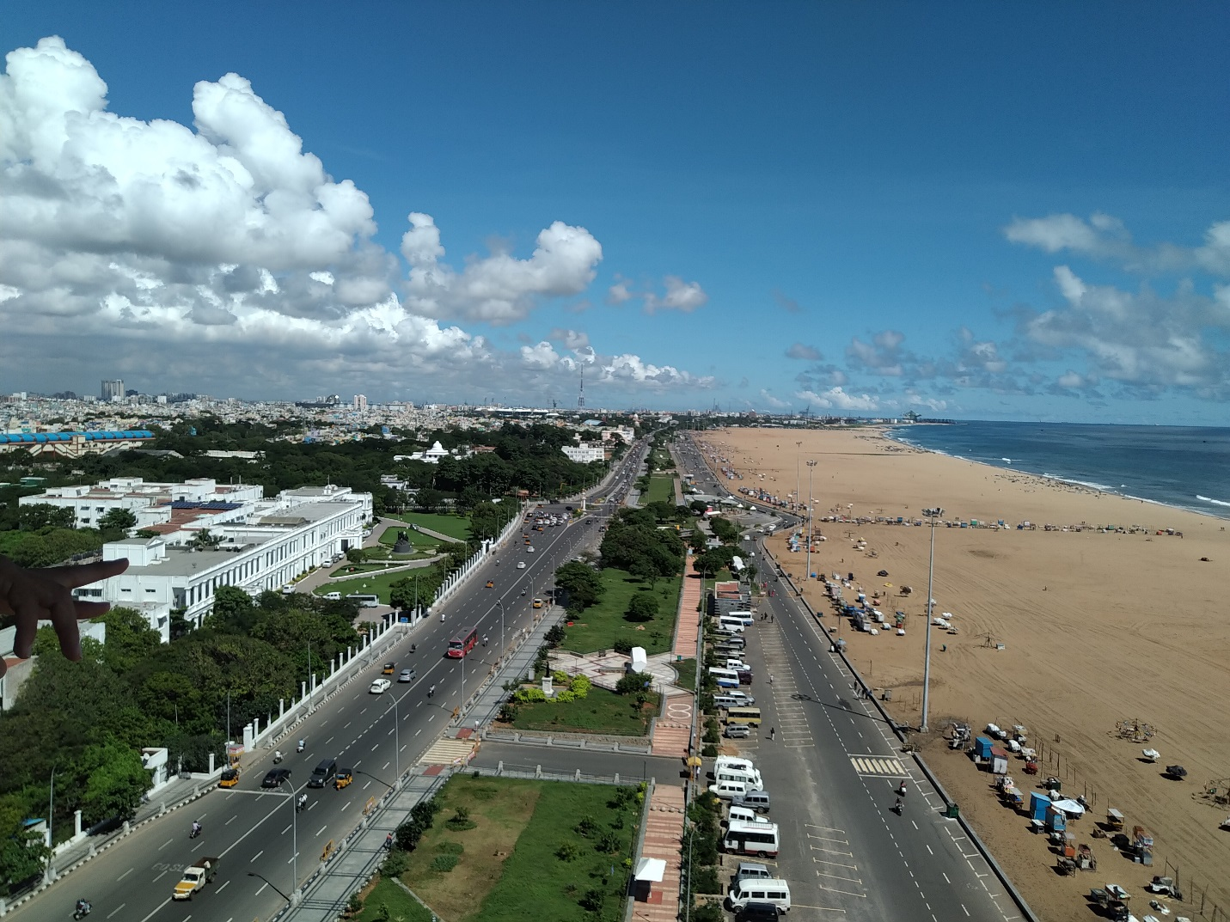**Exploring Chennai, Tamil Nadu, India**

**2. Data**

I will use foursquare API to collect data about restaurants in Chennai. I need data about different venues around Chennai.

In order to gain that information we will use “Foursquare” locational information. Foursquare is a location data provider with information about all manner of venues and events within an area of interest. Such information includes venue names, locations, menus and even photos. As such, the foursquare location platform will be used as the sole data source since all the stated required information can be obtained through the API.

After finding the list of neighborhoods, we then connect to the Foursquare API to gather information about venues inside each and every neighborhood.

The data retrieved from Foursquare contained information of venues within a specified distance of the longitude and latitude of the postcodes.

Interactive maps are useful for data exploration and communicating research. Folium package will be used to:

a. Create a map centered at an inputted location

b. Create marker on the map

Markers can be extremely useful for storing information about locations on the map such as cross streets, building information, etc.